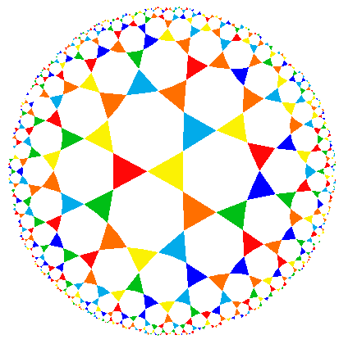
MAKO Undergraduate Mathematics
Research Conference – 2016
Saturday, November 12

Schedule

9:00 am – 9:05 am | Welcome: Bill Bray, Mathematics Department Head, MSU
9:05 am – 9:25 am | “The Game of Seepage”  Julie Anne Bowman, Southwest Baptist University
9:30 am – 9:55 am | “Global Stability Analysis of Zika Virus Dynamics”  Savannah Bates, Jacksonville University,  and Hayley Hutson, Missouri State University
10:00 am – 10:25 am | “Rainbow Arithmetic Triples”  Rafael Ceja, California State University, Sacramento,  Kathryn Cook, Evangel University,  and Karissa Hayden-Gill, University of California, Davis
10:30 am – 10:55 am | “Delay Differential Equations for Population Modeling”  Nathaniel Covey, Lyon College
11:00 am – 11:25 am | “Simplexes in an N-Dimensional Cube”  John Carter, Missouri State University
11:30 am – 11:55 am | “Predator-Prey Models with Harvesting”  Jacob Perkins, Lyon College
noon – 12:25 pm | Lunch – Cheek Lobby
12:30 pm – 12:55 pm | “Investigating Graphs Based on Relationships of Three 3 Vertices”  Jon Mangum, Missouri State University
1:00 pm – 1:25 pm | “Analyzing the Stability of Ebola Models Using Dynamical Systems”  Tommy Stoller, Wichita State University
1:30 pm – 1:55 pm | “Some Applications of Additive Combinatorics in Finite Fields”  Mengqing Qin, Missouri State University
2:00 pm – 2:25 pm | “Differential Equations as Physical Models”  Morgan Webb, Lyon College  and Jacob Perkins, Lyon College
2:30 pm – 2:55 pm | “Integer Partition Theory”  Jon Rehmert, College of the Ozarks
3:00 pm – 3:25 pm | “Mathematical Modeling of Japanese Knotweed”  Jessica Linton, Benedictine College
3:25 pm – 3:30 pm | Closing and final remarks

