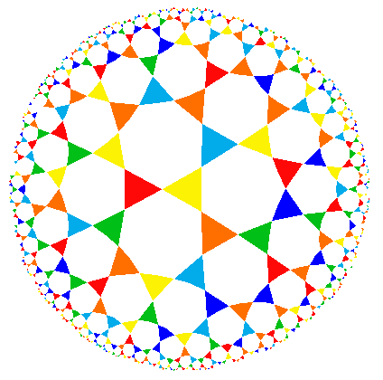
MAKO Undergraduate Mathematics
Research Conference – 2025
Saturday, November 15

Schedule

Note: This schedule is tentative. If a speaker finishes early, we will start up again after a five-minute break. This excludes the Zoom talk, which will occur at the scheduled time.

8:30 am – 9:00 am | Coffee and Pastries – Outside Hill Hall 001
9:00 am – 9:05 am | Welcome
9:05 am – 9:55 am | Invited Talk: “Bernoulli Numbers”  Dr. Songfeng Zheng, Missouri State University
10:00 am – 10:25 am | “Where Cars Meet Combinatorics: A Presentation on Parking Functions”  Isaiah Holgerson, Evangel University
10:30 am – 10:55 am | “The Impact of Prior Mathematics Experience on College Students' Mathematical Beliefs and Anxiety”  Ethan Tritch, University of Central Arkansas
11:00 am – 11:25 am | “Fostering Mathematical Creativity in Teachers: An Examination of Problem Posing and its Impact on Fluency, Flexibility, and Originality”  Jewel Madison Fetterly, University of Central Arkansas
11:30 am – 11:55 pm | “VC-Dimension of Subsets of Hamming Graphs”  Chris Housholder, Missouri State University
noon – 12:25 pm | Lunch – Outside Hill Hall 001
12:30 pm – 12:55 pm | “Spanning Trees in Chair-Free Graphs”  Serenity Biggs, University of Arkansas
1:00 pm – 1:25 pm | via Zoom  “Alternating Sequences of Sum and Difference Dominated Sets”  Yorick Herrmann, University of California, Irvine, Merlin Phillips, University of Minnesota, and Connor Hill, Shenandoah University
1:30 pm – 1:55 pm | “Analyzing Cardiovascular and Kidney Disease Risks Among Diverse Populations with Type 2 Diabetes Using Compartmental Modeling and the NIH All of Us Database”  Jackson Deal, Southwest Baptist University
2:00 pm – 2:25 pm | “Modelling Wait Times for Local Doctors’ Offices”  Sam Stagner and Jan Dueppe, Drury University
2:30 pm – 2:55 pm | “A Reversed -Shaped Bifurcation Curve for a Class of Superlinear Boundary-Value Problems”  Loren Baker, University of Central Missouri
3:00 pm – 3:25 pm | “An Alternative Proof of the Newton-Girard Formula for Non-Commutative Symmetric Polynomials”  Tim Fay, William Jewell College
3:30 pm – 3:55 pm | “Mastermind”  Erin Hancock, Evangel University
4:00 pm – 4:05 pm | Final Remarks

