MAKO Puzzles, 2025

A perfect cube

Find the smallest perfect cube that begins with the digits 2025.

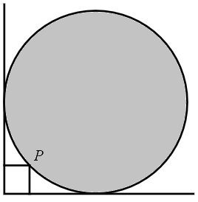
What is the radius of the table?

A circular table is pushed into the corner of a square room so that a point P on the edge of the table is 8 inches from one wall and 9 inches from the other wall, as shown. Fine the radius of the table.

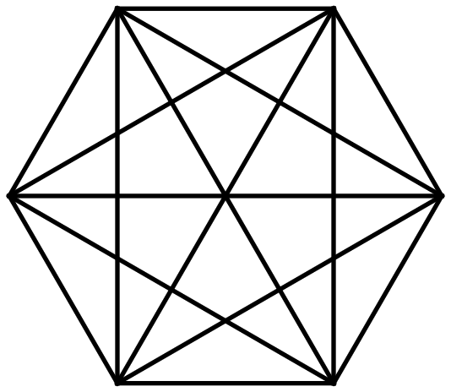
How many triangles?

What is the total number of triangles in the figure shown?

Maximize the product

A sum of a collection of positive integers is 100. What is the greatest possible product of those integers?

How many bags?

What is the greatest number of bags that can be used to hold 1000 marbles if each bag must contain at least one marble but no two bags may contain the same number of marbles?

Odd numbers in Pascal’s triangle
How many odd numbers are in row 100 of Pascal’s triangle (the row corresponding to the expansion of )?

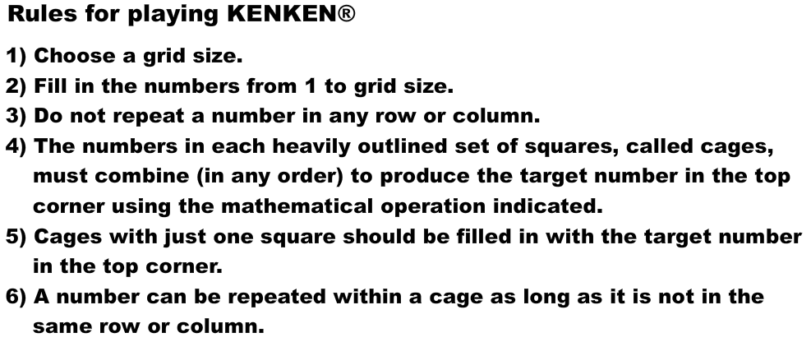

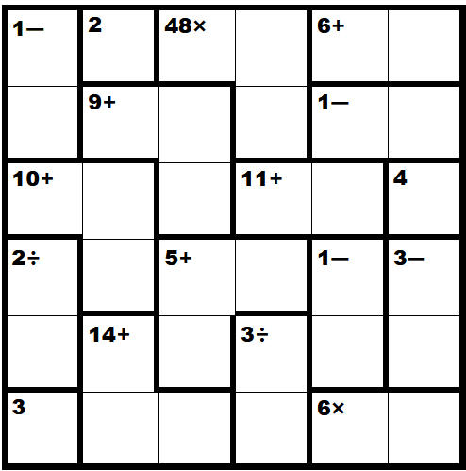

More KenKen at http://www.kenken.com

Kakuro is like a crossword puzzle with numbers. Each “word” must add up to the number provided in the clue above it or to the left. Words can only use the numbers 1 through 9, and a given number can only be used once in a word.

